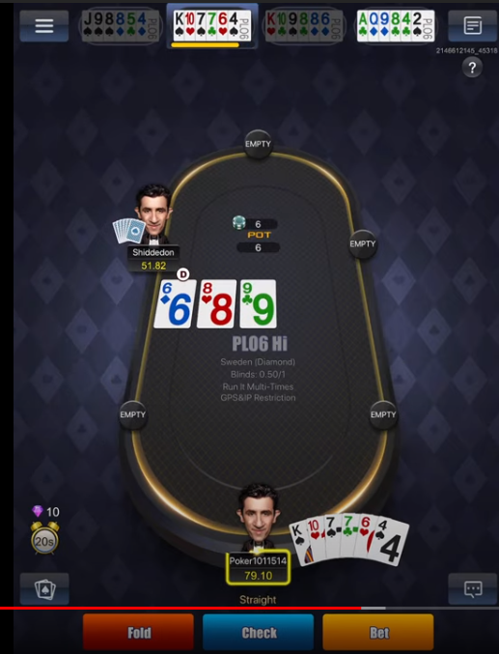
1. At the top you can see 4 tables (represented by my 6 cards on each table), and when you click on one table, it will take you to that table.
- What I need is a clicker to click on each of the tables, starting with the furthest left, and going right one place at a time. Until we see a yellow bar- in the sceenshot you see the yellow bar at the top, and also at the bottom of the screen. When we see this yellow bar, I need the clicker to stop cling the tables, and I want to run my Python script. See point 3. for which python script to run; there are only 2 python scripts.

2. My python script will return ‘Fold’, ‘Check’ or ‘Bet’, and I need to click on this button (you can see the buttons at the bottom of the screen).
- note that for ‘Fold’ and ‘Check’ we just need to click a button, for for ‘Bet’, we have a second button to click- see Screenshot 2 below.

Screenshot2

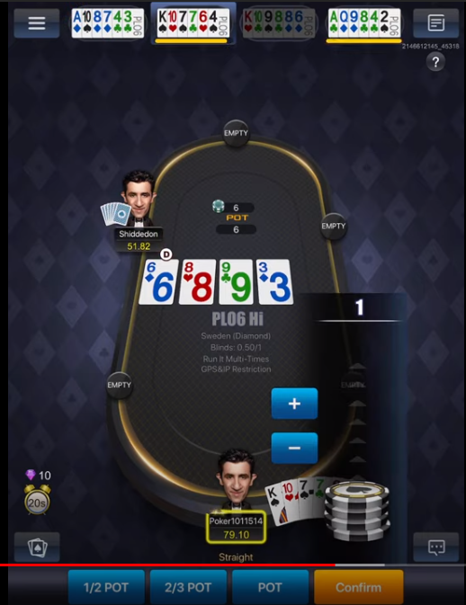
- As you can see, when we click on ‘Bet’, now we can see the amount to bet. So next click on ‘POT’ (this may change in the future but for now we always just click‘Pot’)

- Then after clicking ‘POT’, we finally need to click on ‘Confirm’

- Then we go back to the clicker clicking on the tables.

3. which python script to run when we have stopped the clicker (there are a total of 4 scenarios; pre_flop, flop, turn and river)

- pre_flop: when there are no cards in the middle
-flop: when there are 3 cards in the middle
-turn: when there are 4 cards in the middle
-river: when there are 5 cards in the middle

pre_flop – run “pre_flop_play.py” script
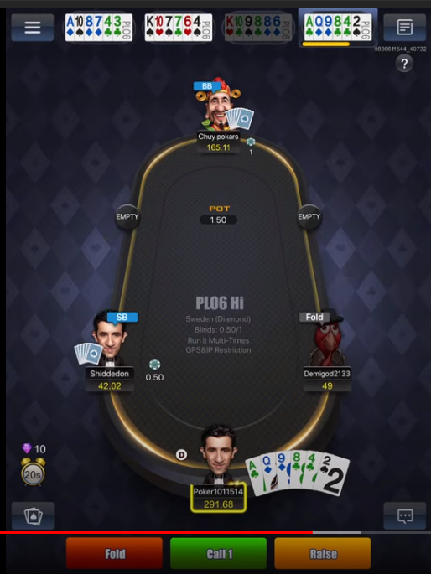

Flop- run post_flop_play; Postflopplay.on_flop()

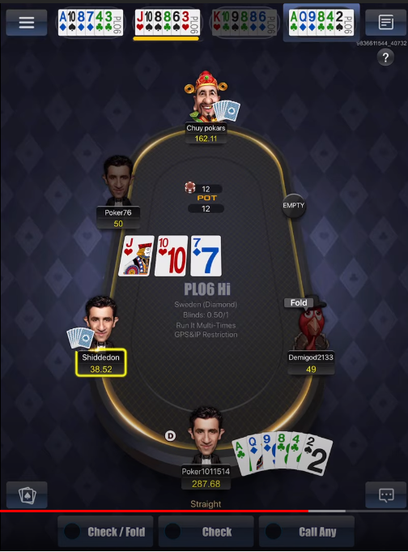

Turn- run post_flop_play; Postflopplay.on_turn()

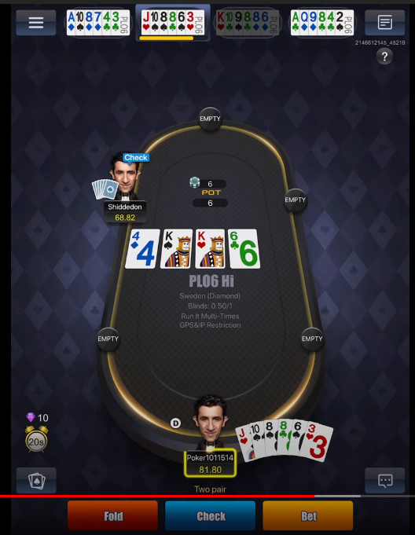

Turn- run post_flop_play; Postflopplay.on_river()

